**Ethical Considerations**

|  |  |  |  |  |
| --- | --- | --- | --- | --- |
|  | **Weight** | **Aus** | **Ban** | **Can** |
| **Human Rights** | **0.40** | 1 | 0.1 | 0.95 |
| **Emissions** | **0.50** | 0.81 | 0 | 1 |
| **Employees** | **0.10** | 0.66 | 1 | 0.83 |
| **TOTAL** | **1** | 0.871 | 0.14 | 0.963 |

**Profit Considerations**

|  |  |  |  |  |
| --- | --- | --- | --- | --- |
|  | 10Years | 10Y (Norm) | 25Years | 25Y (Norm) |
| Aus | $16,806,462 | 0.5441 | $34,372,217 | 0.6229 |
| Ban | $30,890,079 | 1 | $55,177,189 | 1 |
| Can(No PD) | $18,300,353 | 0.5924 | $37,275,838 | 0.6756 |

|  |  |  |  |  |
| --- | --- | --- | --- | --- |
|  | **Weight** | **Aus** | **Ban** | **Can** |
| **Short Term** | **0.4** | 0.544 | 1 | 0.592 |
| **Long Term** | **0.6** | 0.623 | 1 | 0.676 |
| **Total** | **1** | 0.591 | 1 | 0.642 |

**Scales**

|  |  |  |
| --- | --- | --- |
|  | **Ethics Only** | **Profit Only** |
| **Aus** | 0.871 | 0.591 |
| **Ban** | 0.14 | 1 |
| **Can** | 0.963 | 0.642 |

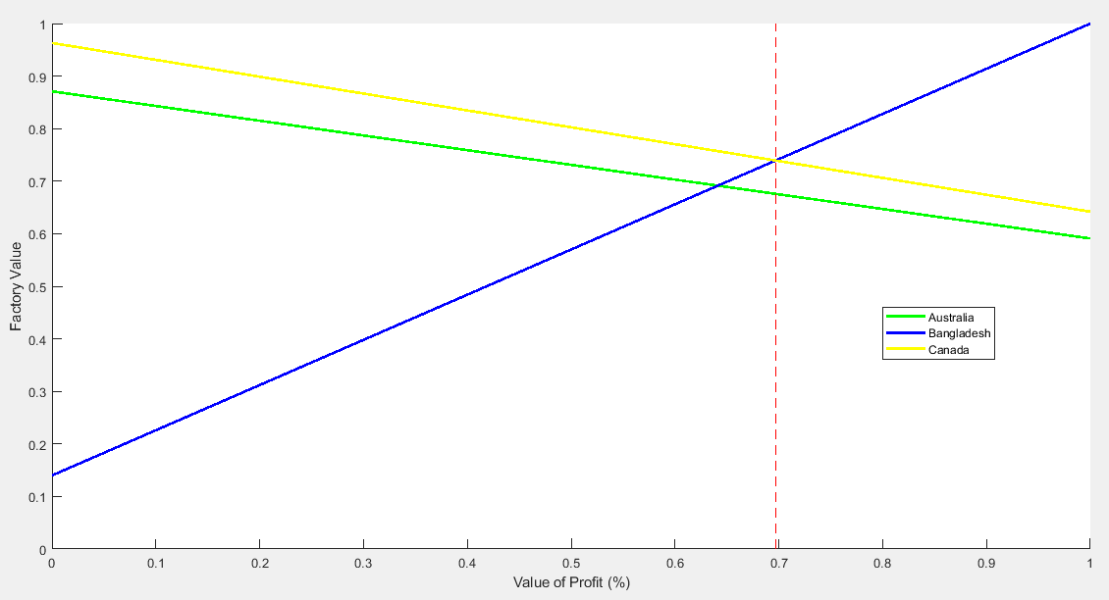

**Profit % Weight Cut-Off Point**

**Ban(t)=** (1) *t + 0.14*(1-t)

**Can(t)=** (0.642) *t + 0.963* (1-t)

h(t) = Can(t)-Ban(t) = (-0.358) *t + (0.823) *(1-t) = (-0.358-0.823) *t +0.823

= (-1.181) *t +0.823

h(t) =0 when (-1.181)*t +0.823 = 0,

When 1.181*t = 0.823, t=0.823/1.181 = 0.697

Therefore, If Profit is weighed less than 69.7%, best option is Canada. Else, best option is Bangladesh.

**Recommendation**

**Canada:** As Expecting Profit to be weighted around 30-40%, implying Canada is the best location for the new factory.